**Pertemuan 8 : CRUD 2**

**Tugas 8 : Widget, CRUD, dan Laporan**

|  |  |
| --- | --- |
| **Nama / Nim** | **: (2218125)** |
| **Kelas** | **:** |
| **Pengajar** | **:** **()** |

* 1. **Tujuan**

1. Mampu menghubungkan antara Database dengan PHP.
2. Mampu memahami penggunaan CRUD.
3. Mampu membuat Report.
   1. **Alat dan Bahan**
4. Laptop/pc
5. Modul Praktikum Web 2024
6. TextEditor (Visual Studio Code / Sublime Text)
   1. **Langkah-langkah**
7. Widget

Source code widget.php:

|  |
| --- |
| <?php  $servername = "localhost";  $username = "root";  $password = "";  $dbname = "topup_game";  // Create connection  $conn = new mysqli($servername, $username, $password, $dbname);  // Check connection  if ($conn->connect_error) {  die("Connection failed: " . $conn->connect_error);  }  $user_count = $conn->query("SELECT COUNT(*) AS count FROM tb_user")->fetch_assoc()['count'];  $item_count = $conn->query("SELECT COUNT(*) AS count FROM tb_item")->fetch_assoc()['count'];  $pembelian_count = $conn->query("SELECT COUNT(*) AS count FROM tb_pembelian")->fetch_assoc()['count'];  $conn->close();  echo json_encode([  'user_count' => $user_count,  'item_count' => $item_count,  'pembelian_count' => $pembelian_count  ]);  ?> |

Source code dashboard.php:

|  |
| --- |
| <?php  session_start();  if ($_SESSION['username'] == null) {  header('location: ../LOGIN.php');  }  ?>  <!DOCTYPE html>  <html lang="en">  <head>  <meta charset="UTF-8">  <meta name="viewport" content="width=device-width, initial-scale=1.0">  <title>Tabel dengan Sidebar</title>  <link rel="stylesheet" href="style.css">  <style>  body {  font-family: Arial, sans-serif;  display: flex;  justify-content: center;  align-items: center;  margin: 0;  background-color: #f0f0f0;  }  .widget-container {  display: flex;  gap: 20px;  }  .widget {  background: #fff;  padding: 20px;  border-radius: 8px;  box-shadow: 0 0 10px rgba(0, 0, 0, 0.1);  text-align: center;  }  .widget h2 {  margin: 0;  font-size: 24px;  color: #333;  }  .widget p {  font-size: 36px;  margin: 10px 0 0;  color: #666;  }  </style>  </head>  <body>  <div class="container">  <div class="sidebar">  <h2>Top Up</h2>  <ul>  <li><a href="dashboard.php">Dashboard</a></li>  <li><a href="Item.php">Item</a></li>  <li><a href="penjualan.php">Pembelian</a></li>  <li><form action="../logout.php" method="post">  <button name="logout">Log Out</button>  </form></li>  </ul>  </div>  <div class="main-content">  <h1>Selamat Datang Di Dashboard Admin</h1>  <div class="widget-container">  <div class="widget" id="user-count">  <h2>Users</h2>  <p id="user-count-value">0</p>  </div>  <div class="widget" id="item-count">  <h2>Items</h2>  <p id="item-count-value">0</p>  </div>  <div class="widget" id="pembelian-count">  <h2>Pembelian</h2>  <p id="pembelian-count-value">0</p>  </div>  </div>  </div>  </div>  <script src="script.js"></script>  </body>  </html> |

Source code script.js:

|  |
| --- |
| document.addEventListener('DOMContentLoaded', function() {  fetch('get-count.php')  .then(response => response.json())  .then(data => {  document.getElementById('user-count-value').textContent = data.user_count;  document.getElementById('item-count-value').textContent = data.item_count;  document.getElementById('pembelian-count-value').textContent = data.pembelian_count;  })  .catch(error => console.error('Error fetching data:', error));  }); |

Hasil Tampilan :

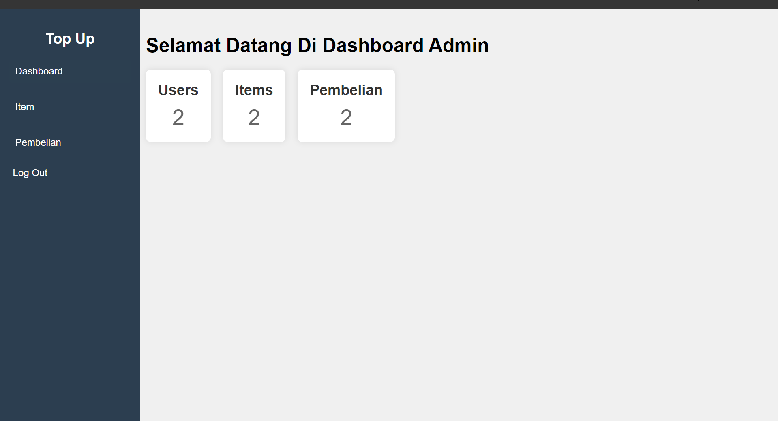

Gambar 8.1 Tampilan Dashboard

Analisa :

Kode di atas terdiri dari dua bagian: skrip PHP dan JavaScript. Skrip PHP menghubungkan ke database MySQL bernama topup_game, menghitung jumlah baris dalam tabel tb_user, tb_item, dan tb_pembelian, kemudian mengembalikan hasilnya dalam format JSON. Skrip JavaScript dijalankan setelah halaman dimuat (DOMContentLoaded), yang melakukan permintaan fetch ke skrip PHP (get-count.php) untuk mendapatkan data JSON tersebut. Data yang diterima kemudian digunakan untuk memperbarui teks dalam elemen HTML dengan ID user-count-value, item-count-value, dan pembelian-count-value, menampilkan jumlah pengguna, item, dan pembelian secara dinamis di halaman web.

1. CRUD

Source code pembelian-proses.php:

|  |
| --- |
| <?php  session_start();  include '../koneksi.php';  if (isset($_POST['simpan'])) {  $game = $_POST['game'];  $server = $_POST['server'];  $id_user = $_SESSION['id_user'];  $id_pembelian = $_POST['topup'];  $metode = $_POST['metode'];  $sql = "INSERT INTO tb_pembelian VALUES(null, '$game','$server','$id_user', '$id_pembelian', '$metode')";  if (empty($game) || empty($server) || empty($id_user) || empty($id_pembelian) || empty($metode)) {  echo "  <script>  alert('Pastikan Anda Mengisi Semua Data');  window.location = 'penjualan-input.php';  </script>  ";  } elseif (mysqli_query($koneksi, $sql)) {  echo "  <script>  alert('Transaction Berhasil');  window.location = 'penjualan.php';  </script>  ";  } else {  echo "  <script>  alert('Terjadi Kesalahan');  window.location = 'penjualan-input.php';  </script>  ";  }  }elseif (isset($_POST['edit'])) {  $id = $_POST['id'];  $game = $_POST['game'];  $server = $_POST['server'];  $id_user = $_SESSION['id_user'];  $id_pembelian = $_POST['topup'];  $metode = $_POST['metode'];  if (empty($game) || empty($server) || empty($id_user) || empty($id_pembelian) || empty($metode)) {  echo "  <script>  alert('Pastikan Anda Mengisi Semua Data');  window.location = 'penjualan-edit.php?id=$id';  </script>  ";  } else {  $sql = "UPDATE tb_pembelian SET game = '$game', server = '$server', id_user = '$id_user', id_pembelian = '$id_pembelian', metode = '$metode' WHERE id_pembelian = '$id'";    if (mysqli_query($koneksi, $sql)) {  echo "  <script>  alert('Transaction Berhasil');  window.location = 'penjualan.php';  </script>  ";  } else {  echo "  <script>  alert('Terjadi Kesalahan');  window.location = 'penjualan-edit.php?id=$id';  </script>  ";  }  }  }elseif(isset($_POST['hapus'])) {  $id = $_POST['id'];  // hapus gambar  $sql = "SELECT * FROM tb_pembelian WHERE id_pembelian = $id";  $result = mysqli_query($koneksi, $sql);  $row = mysqli_fetch_assoc($result);    $sql = "DELETE FROM tb_pembelian WHERE id_pembelian = $id";  if(mysqli_query($koneksi, $sql)) {  echo "  <script>  alert('Data Item Berhasil Dihapus');  window.location = 'penjualan.php';  </script>  ";  }else {  echo "  <script>  alert('Data Item Gagal Dihapus');  window.location = 'penjualan.php';  </script>  ";  }  } else {  header('location: ../HOME.php');  } |

Source code pembelian.php:

|  |
| --- |
| <?php  session_start();  if ($_SESSION['username'] == null) {  header('location: ../LOGIN.php');  }  include '../koneksi.php'; // Pastikan file koneksi ada dan benar  // Query untuk mengambil data pembelian  $query = "  SELECT  tb_pembelian.id_pembelian,  tb_pembelian.game,  tb_pembelian.server,  tb_user.username,  tb_item.nama_item,  tb_pembelian.metode  FROM tb_pembelian  INNER JOIN tb_user ON tb_pembelian.id_user = tb_user.id_user  INNER JOIN tb_item ON tb_pembelian.id_item = tb_item.id_item  ";  $result = mysqli_query($koneksi, $query);  ?>  <!DOCTYPE html>  <html lang="en">  <head>  <meta charset="UTF-8">  <meta name="viewport" content="width=device-width, initial-scale=1.0">  <title>Tabel dengan Sidebar</title>  <link rel="stylesheet" href="style.css">  <style>  .main-content .input{  color: #fff;  padding: 10px;  margin: 10px 0;  text-decoration: none;  background-color: #1758a1;  border-radius: 5px;  }  </style>  </head>  <body>  <div class="container">  <div class="sidebar">  <h2>Top Up</h2>  <ul>  <li><a href="dashboard.php">Dashboard</a></li>  <li><a href="Item.php">Item</a></li>  <li><a href="penjualan.php">Pembelian</a></li>  <li><form action="../logout.php" method="post">  <button name="logout">Log Out</button>  </form></li>  </ul>  </div>  <div class="main-content">  <h1>Data Penbelian</h1>  <a class="input" href="penjualan-input.php">Input Data</a>  <a class="input" href="penjualan-laporan.php">Buat Laporan</a>  <table>  <thead>  <tr>  <th>No</th>  <th>ID Game</th>  <th>Server</th>  <th>username</th>  <th>Nama Item</th>  <th>Metode Pembayaran</th>  <th>Action</th>  </tr>  </thead>  <tbody>  <?php  if (mysqli_num_rows($result) > 0) {  $no = 1;  while ($row = mysqli_fetch_assoc($result)) {  echo "  <tr>  <td>{$no}</td>  <td>{$row['game']}</td>  <td>{$row['server']}</td>  <td>{$row['username']}</td>  <td>{$row['nama_item']}</td>  <td>{$row['metode']}</td>  <td>  <a class='btn-edit' href='penjualan-edit.php?id={$row['id_pembelian']}'>Edit</a>  <a class='btn-hapus' href='penjualan-hapus.php?id={$row['id_pembelian']}'>Hapus</a>  </td>  </tr>  ";  $no++;  }  } else {  echo "  <tr>  <td colspan='6'>Tidak ada data.</td>  </tr>  ";  }  ?>  </tbody>  </table>  </div>  </div>  </body>  </html> |

Hasil Tampilan :

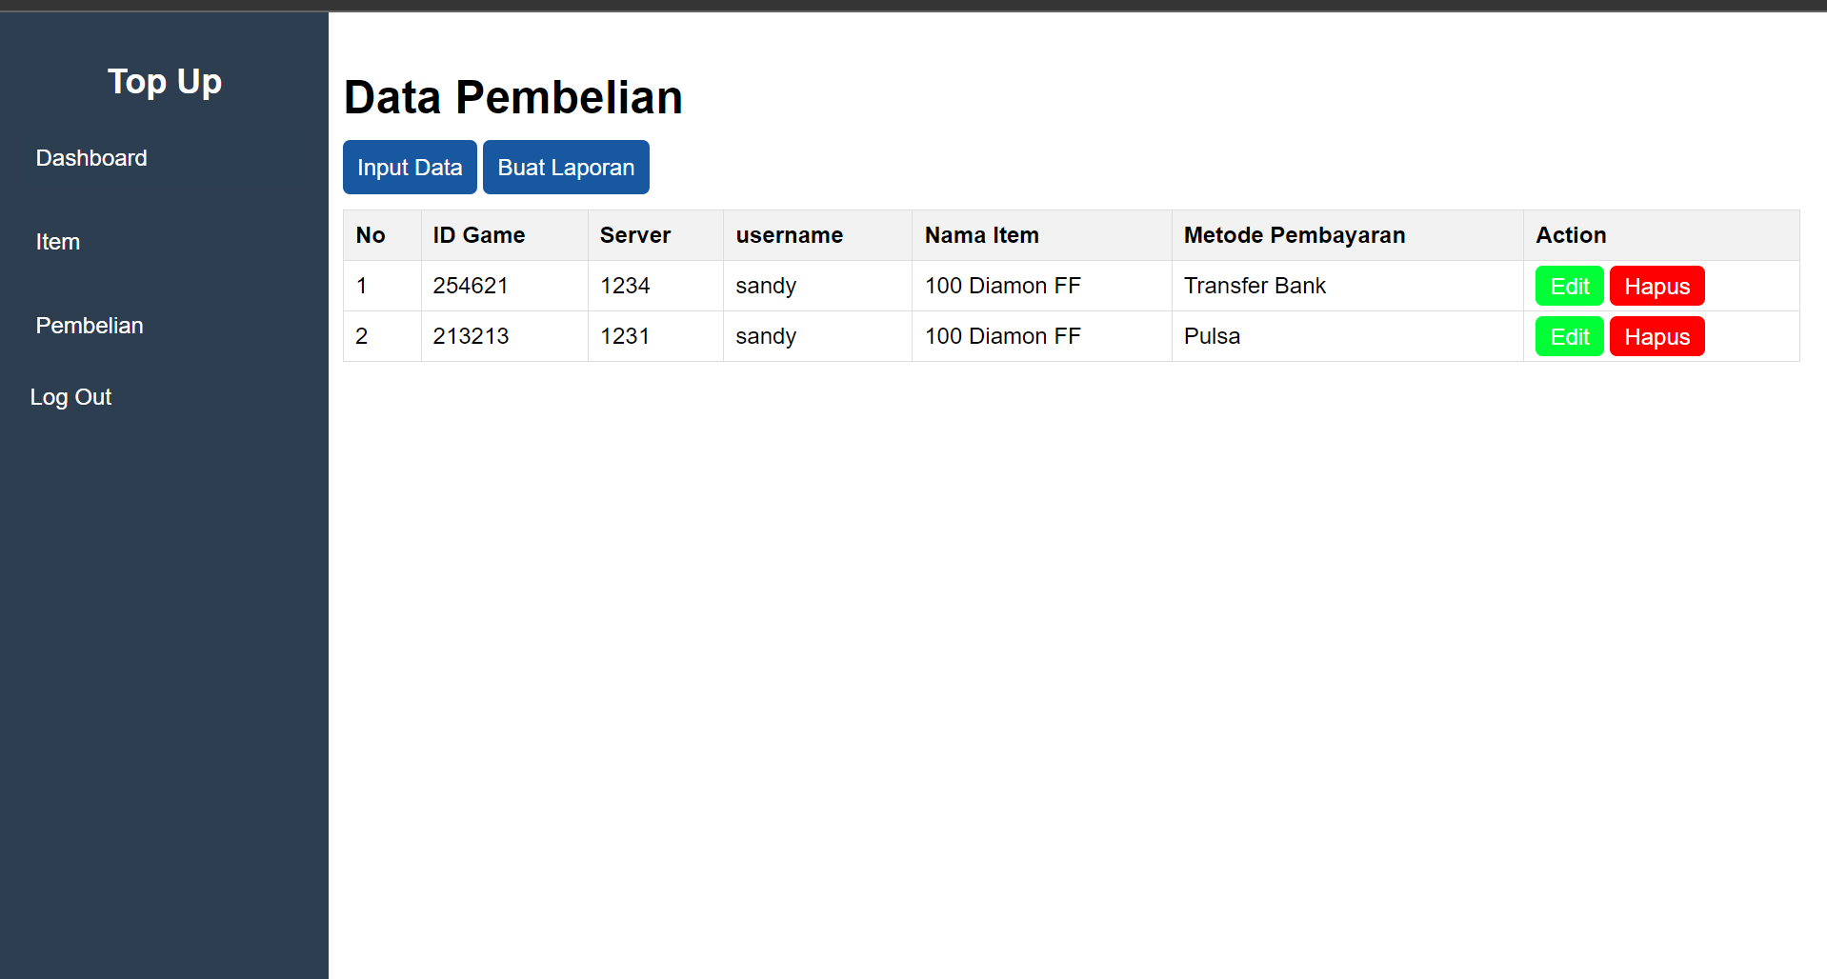

Gambar 8.2 Tampilan Data

Source code pembelian-input.php:

|  |
| --- |
| <?php  include '../koneksi.php';  // Ambil data dari tabel tb_item  $itemQuery = "SELECT id_item, nama_item FROM tb_item";  $itemResult = mysqli_query($koneksi, $itemQuery);  session_start();  if ($_SESSION['username'] == null) {  header('location: ../LOGIN.php');  }  ?>  <!DOCTYPE html>  <html lang="en">  <head>  <meta charset="UTF-8">  <meta name="viewport" content="width=device-width, initial-scale=1.0">  <title>Tabel dengan Sidebar</title>  <link rel="stylesheet" href="style.css">  <style>  .main-content .input{  color: #fff;  padding: 10px;  margin: 10px 0;  text-decoration: none;  background-color: #1758a1;  border-radius: 5px;  }  form{  margin-top: 20px;  }  .form-group{  font-size: 20px;  }  .form-group input{  width: 100%;  height: 20px;  margin-bottom: 10px;  }  form button{  font-size: 15px;  background-color: #00ff37;  border: none;  border-radius: 5px;  padding: 8px;  color: #fff;  }  .log{  background-color: transparent;  }  </style>  </head>  <body>  <div class="container">  <div class="sidebar">  <h2>Top Up</h2>  <ul>  <li><a href="dashboard.php">Dashboard</a></li>  <li><a href="Item.php">Item</a></li>  <li><a href="penjualan.php">Pembelian</a></li>  <li><form action="../logout.php" method="post">  <button class="log" name="logout">Log Out</button>  </form></li>  </ul>  </div>  <div class="main-content">  <h1>Input Data Pembelian</h1>  <a class="input" href="item.php">Batal</a>  <form action="penjualan-proses.php" method="post">  <div class="form-group">  <input type="number" id="game" name="game" placeholder="ID Game" required>  </div>  <div class="form-group">  <input type="number" id="server" name="server" placeholder="ID Server" required>  </div>  <div class="form-group">  <select id="topup" name="topup" style="text-align: center;" required>  <option value="">--- Pilih Jumlah Top Up ---</option>  <?php  while ($item = mysqli_fetch_assoc($itemResult)) {  echo "<option value='{$item['id_item']}'>{$item['nama_item']}</option>";  }  ?>  </select>  </div>  <div class="form-group">  <select id="metode" name="metode" style="text-align: center;" required>  <option value="">--- Pilih Metode Pembayaran ---</option>  <option value="Indomart">Indomart</option>  <option value="Alfamart">Alfamart</option>  <option value="Transfer Bank">Transfer Bank</option>  <option value="Pulsa">Pulsa</option>  </select>  </div>  <button type="submit" name="simpan">Kirim</button>  </form>  </div>  </div>  </body>  </html> |

Hasil Tampilan :

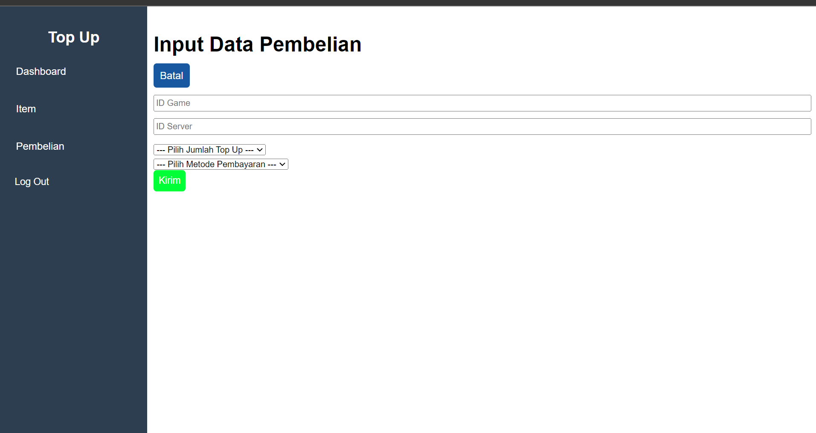

Gambar 8.3 Tampilan Tambah Data

Source code form pembelian-edit.php:

|  |
| --- |
| <?php  include '../koneksi.php';  session_start();  if (!isset($_SESSION['username'])) {  header('location: ../LOGIN.php');  exit;  }  if (!isset($_GET['id'])) {  echo "  <script>  alert('Tidak ada ID yang Terdeteksi');  window.location = 'penjualan.php';  </script>  ";  exit;  }  $id = $_GET['id'];  $query = "SELECT * FROM tb_pembelian WHERE id_pembelian = '$id'";  $result = mysqli_query($koneksi, $query);  $data = mysqli_fetch_assoc($result);  $itemQuery = "SELECT id_item, nama_item FROM tb_item";  $itemResult = mysqli_query($koneksi, $itemQuery);  ?>  <!DOCTYPE html>  <html lang="en">  <head>  <meta charset="UTF-8">  <meta name="viewport" content="width=device-width, initial-scale=1.0">  <title>Edit Data Item</title>  <link rel="stylesheet" href="style.css">  <style>  .main-content .input{  color: #fff;  padding: 10px;  margin: 10px 0;  text-decoration: none;  background-color: #1758a1;  border-radius: 5px;  }  form{  margin-top: 20px;  }  .form-group{  font-size: 20px;  }  .form-group input{  width: 100%;  height: 20px;  margin-bottom: 10px;  }  form button{  font-size: 15px;  background-color: #00ff37;  border: none;  border-radius: 5px;  padding: 8px;  color: #fff;  }  </style>  </head>  <body>  <div class="container">  <div class="sidebar">  <h2>Top Up</h2>  <ul>  <li><a href="dashboard.php">Dashboard</a></li>  <li><a href="Item.php">Item</a></li>  <li><a href="penjualan.php">Pembelian</a></li>  <li>  <form action="../logout.php" method="post">  <button name="logout">Log Out</button>  </form>  </li>  </ul>  </div>  <div class="main-content">  <h1>Edit Data Pembelian</h1>  <a class="input" href="penjualan.php">Batal</a>  <form action="penjualan-proses.php" method="post">  <input type="hidden" name="id" value="<?= htmlspecialchars($data['id_pembelian']) ?>">  <div class="form-group">  <input type="number" id="game" name="game" placeholder="ID Game" value="<?= htmlspecialchars($data['game']) ?>" required>  </div>  <div class="form-group">  <input type="number" id="server" name="server" placeholder="ID Server" value="<?= htmlspecialchars($data['server']) ?>" required>  </div>  <div class="form-group">  <select id="topup" name="topup" style="text-align: center;" required>  <option value="">--- Pilih Jumlah Top Up ---</option>  <?php  while ($item = mysqli_fetch_assoc($itemResult)) {  $selected = $item['id_item'] == $data['id_item'] ? 'selected' : '';  echo "<option value='{$item['id_item']}' $selected>{$item['nama_item']}</option>";  }  ?>  </select>  </div>  <div class="form-group">  <select id="metode" name="metode" style="text-align: center;" required>  <option value="">--- Pilih Metode Pembayaran ---</option>  <option value="Indomart" <?= $data['metode'] == 'Indomart' ? 'selected' : '' ?>>Indomart</option>  <option value="Alfamart" <?= $data['metode'] == 'Alfamart' ? 'selected' : '' ?>>Alfamart</option>  <option value="Transfer Bank" <?= $data['metode'] == 'Transfer Bank' ? 'selected' : '' ?>>Transfer Bank</option>  <option value="Pulsa" <?= $data['metode'] == 'Pulsa' ? 'selected' : '' ?>>Pulsa</option>  </select>  </div>  <button type="submit" name="edit">Kirim</button>  </form>  </div>  </div>  </body>  </html> |

Hasil Tampilan :

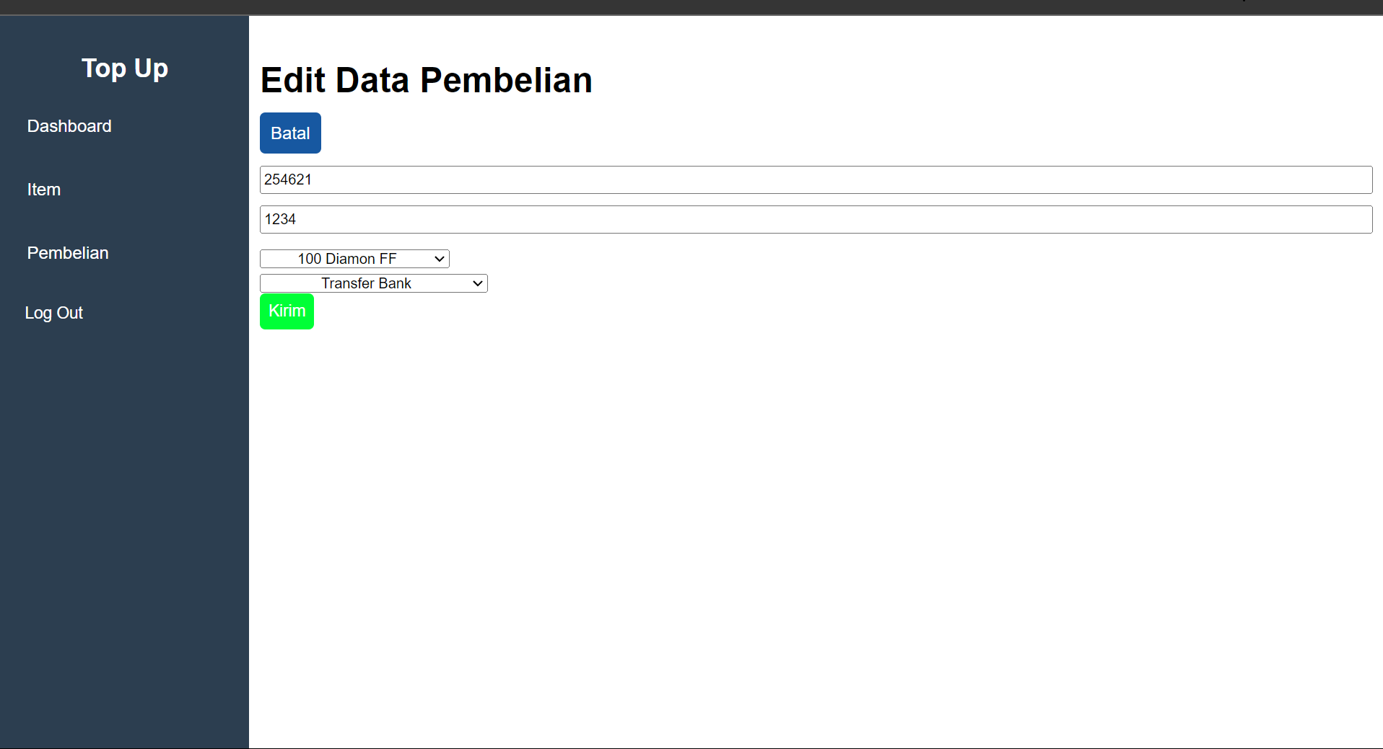

Gambar 8.4 Tampilan Edit Data

Source code form pembelian-hapus.php:

|  |
| --- |
| <?php  include '../koneksi.php';  $id = $_GET['id'];  if(!isset($_GET['id'])) {  echo "  <script>  alert('Tidak ada ID yang Terdeteksi');  window.location = 'penjualan.php';  </script>  ";  }  $sql = "SELECT * FROM tb_pembelian WHERE id_pembelian = '$id'";  $result = mysqli_query($koneksi, $sql);  $data = mysqli_fetch_assoc($result);  session_start();  if ($_SESSION['username'] == null) {  header('location: ../LOGIN.php');  }  ?>  <!DOCTYPE html>  <html lang="en">  <head>  <meta charset="UTF-8">  <meta name="viewport" content="width=device-width, initial-scale=1.0">  <title>Tabel dengan Sidebar</title>  <link rel="stylesheet" href="style.css">  </head>  <body>  <div class="container">  <div class="sidebar">  <h2>Top Up</h2>  <ul>  <li><a href="dashboard.php">Dashboard</a></li>  <li><a href="Item.php">Item</a></li>  <li><a href="penjualan.php">Pembelian</a></li>  <li><form action="../logout.php" method="post">  <button name="logout">Log Out</button>  </form></li>  </ul>  </div>  <div class="main-content">  <h1>Hapus Data Pembelian</h1>  <div>  <h4>Ingin Menghapus Data ?</h4>  <form action="penjualan-proses.php" method="post" >  <input type="hidden" name="id" value="<?= $data['id_pembelian'] ?>">  <button type="submit" class="btn-yes" name="hapus">Yes</button>  <button class="simpan" type="submit" class="btn-no" name="tidak">No</button>  </form>  </div>  </div>  </div>  </body>  </html> |

Hasil Tampilan :



Gambar 8.5 Tampilan Delete Data

Analisa :

Program di atas adalah skrip PHP yang mengelola operasi CRUD untuk data pembelian dalam sebuah aplikasi berbasis web menggunakan database MySQL. Skrip ini mencakup fungsi untuk menambah, mengedit, dan menghapus data pembelian di tabel tb_pembelian. Saat menambah atau mengedit data, skrip memeriksa apakah semua field telah diisi sebelum menyimpan atau memperbarui data di database, dan memberikan umpan balik kepada pengguna melalui alert JavaScript. Jika data berhasil disimpan atau diperbarui, pengguna diarahkan ke halaman penjualan.php. Jika menghapus data, skrip menghapus entri berdasarkan ID-nya dan mengarahkan kembali ke halaman yang sama. Jika tidak ada tindakan yang dikenali, pengguna diarahkan ke halaman utama (../HOME.php). Kode ini juga menggunakan session untuk mendapatkan ID pengguna yang sedang login.

1. Laporan

Source code form pembelian-laporan.php:

|  |
| --- |
| <?php  include('../koneksi.php');  require_once("../dompdf/autoload.inc.php");  use Dompdf\Dompdf;  $dompdf = new Dompdf();  $query = "  SELECT  tb_pembelian.id_pembelian,  tb_pembelian.game,  tb_pembelian.server,  tb_user.username,  tb_item.nama_item,  tb_pembelian.metode  FROM tb_pembelian  INNER JOIN tb_user ON tb_pembelian.id_user = tb_user.id_user  INNER JOIN tb_item ON tb_pembelian.id_item = tb_item.id_item  ";  $result = mysqli_query($koneksi, $query);  $html = '  <style>  table {  width: 100%;  border-collapse: collapse;  }  table, th, td {  border: 1px solid black;  }  th, td {  padding: 8px;  text-align: left;  }  th {  background-color: #f2f2f2;  }  h3 {  margin: 0;  padding: 0;  }  hr {  margin-top: 20px;  margin-bottom: 20px;  }  </style>  ';  $html .= '<center><h3>Data Pembelian</h3></center><hr/><br>';  $html .= '<table width="100%">  <tr>  <th>No</th>  <th>ID Game</th>  <th>Server</th>  <th>username</th>  <th>Nama Item</th>  <th>Metode Pembayaran</th>  </tr>';  $no = 1;  while ($row = mysqli_fetch_array($result)) {  $html .= "<tr>  <td>" . $no . "</td>  <td>" . $row['game'] . "</td>  <td>" . $row['server'] . "</td>  <td>" . $row['username'] . "</td>  <td>" . $row['nama_item'] . "</td>  <td>" . $row['metode'] . "</td>  </tr>";  $no++;  }  $html .= "</table>";  $dompdf->loadHtml($html);  // Setting ukuran dan orientasi kertas  $dompdf->setPaper('A4', 'potrait');  // Rendering dari HTML Ke PDF  $dompdf->render();  // Melakukan output file Pdf  $dompdf->stream('laporan-pembelian.pdf');  ?> |

Hasil Tampilan :

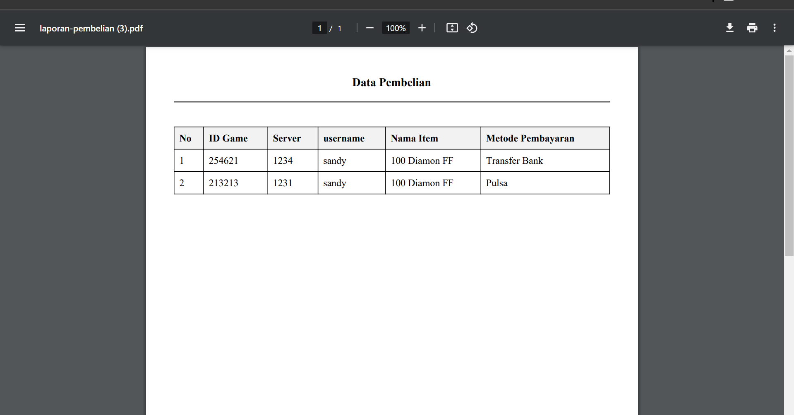

Gambar 8.6 Tampilan Laporan Data

Analisa :

Kode di atas adalah skrip PHP yang menghasilkan laporan PDF dari data pembelian dalam sebuah aplikasi berbasis web menggunakan library Dompdf. Setelah menghubungkan ke database MySQL, skrip mengambil data pembelian dari tabel tb_pembelian, tb_user, dan tb_item melalui sebuah query SQL yang menggunakan INNER JOIN untuk menggabungkan data dari tabel-tabel tersebut. Data yang diambil kemudian diolah menjadi tabel HTML yang diberi gaya menggunakan CSS untuk membuatnya lebih rapi dan mudah dibaca. Skrip kemudian mengonversi HTML tersebut menjadi PDF menggunakan Dompdf, mengatur ukuran kertas ke A4 dengan orientasi potret, dan men-stream hasilnya ke browser sebagai file PDF bernama laporan-pembelian.pdf.